**WEEK 6**

***Student Management Portal***

***Project structure***

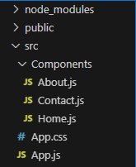

**Src/App.js**

import './App.css';

import Home from './Components/Home';

import About from './Components/About';

import Contact from './Components/Contact';

function App() {

  return (

    <div className="container">

      <Home />

      <About />

      <Contact />

    </div>

  );

}

export default App;

**Src/Components/About.js**

import React, { Component } from 'react';

class About extends Component {

  render() {

    return (

      <div>

        <h3>Welcome to the About Page of Student Management Portal</h3>

      </div>

    );

  }

}

export default About;

**Src/Components/Contact.js**

import React, { Component } from 'react';

class Contact extends Component {

  render() {

    return (

      <div>

        <h3>Welcome to the Contact Page of Student Management Portal</h3>

      </div>

    );

  }

}

export default Contact;

**Src/Components/Home.js**

import React, { Component } from 'react';

class Home extends Component {

  render() {

    return (

      <div>

        <h3>Welcome to the Home Page of Student Management Portal</h3>

      </div>

    );

  }

}

export default Home;

***To run the application***

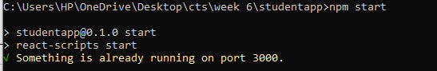

***OUTPUT***

